Customer Behavior Analysis - Complete Project Report

Problem Statement
A leading retail company wants to better understand customers' shopping behavior to improve sales, customer satisfaction and long-term loyalty. The objective is to discover how customer demographics, discounts, reviews, payment methods, seasons and previous purchases influence buying behaviour.
Project Overview
Python was used for data cleaning and feature engineering, MySQL was used to answer business questions through SQL queries, and Power BI was used to build interactive dashboards.
Python Data Cleaning & Preparation
The dataset was explored using head(), info() and describe(). Missing values in Review Rating were filled using the category median. Column names were standardized, Age Group and Purchase Frequency Days were created, Promo Code Used was removed because it duplicated Discount Applied, and the cleaned dataset was uploaded to MySQL.
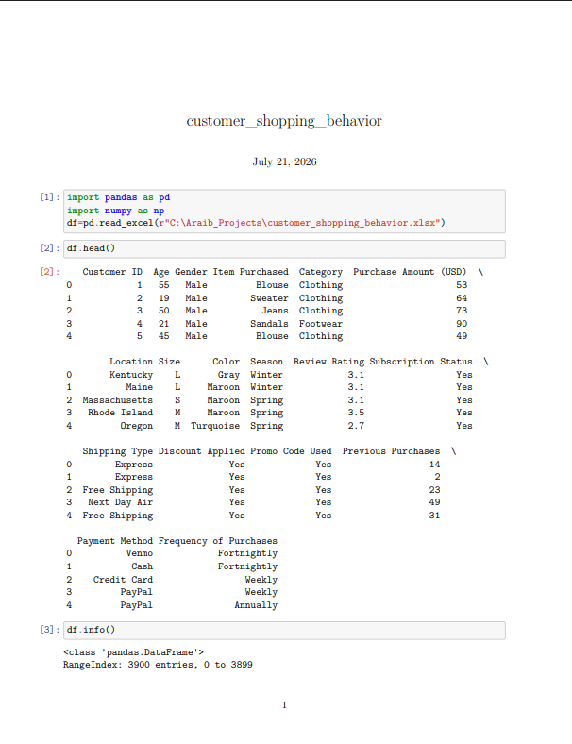
Figure 1: Dataset Loading and Initial Exploration

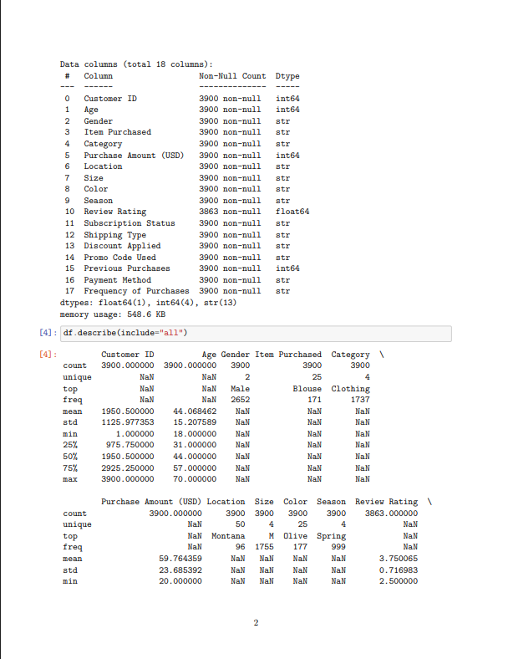

Figure 2: Dataset Information and Summary Statistics

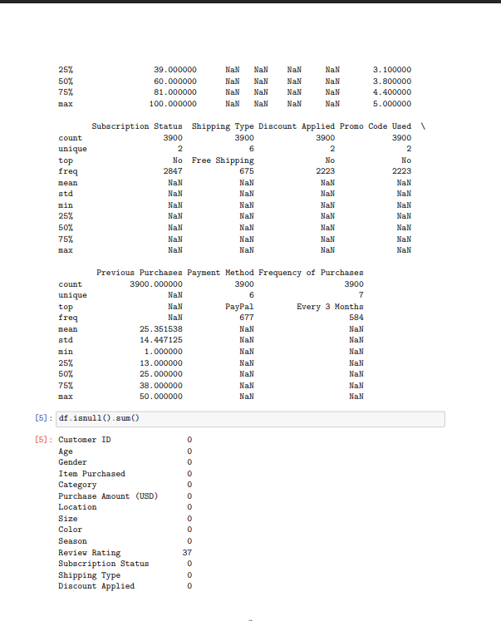

Figure 3: Missing Value Analysis

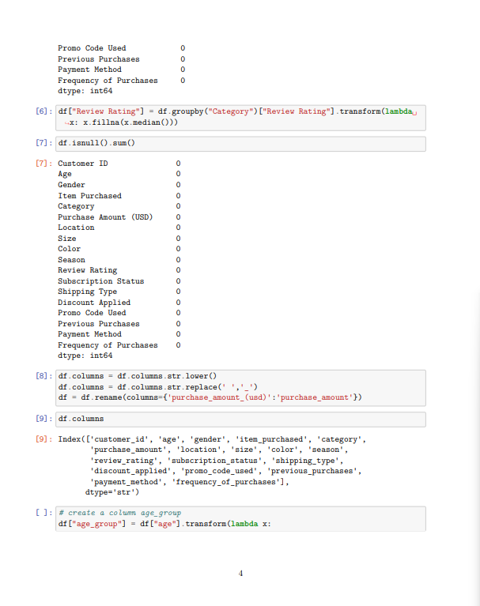

Figure 4: Handling Missing Values and Standardizing Columns

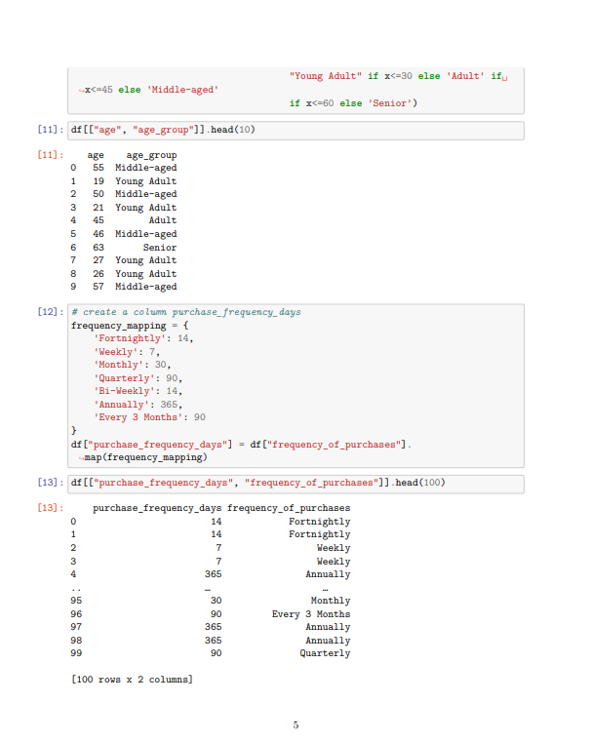

Figure 5: Creating Age Group and Purchase Frequency Days

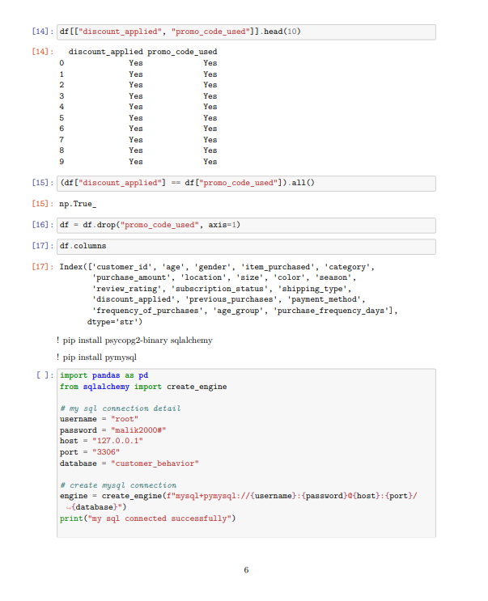

Figure 6: Removing Redundant Column and MySQL Connection

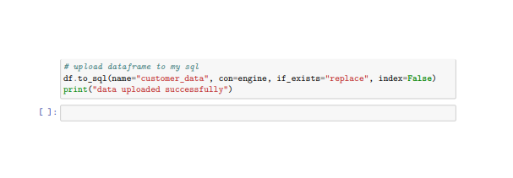

Figure 7: Uploading Cleaned Dataset to MySQL

SQL Business Analysis

Business questions were answered using SQL. Each query helped identify important patterns in customer behaviour.

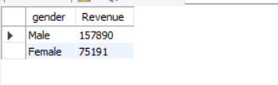
Revenue by Gender
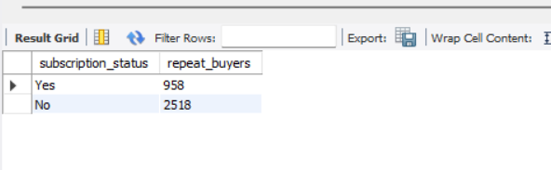
Repeat Buyer by Subscription Status

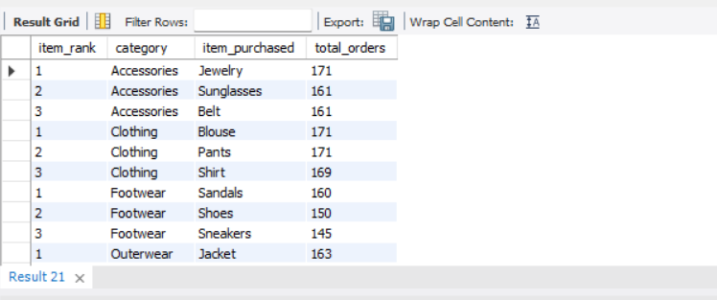
Top 3 Best Selling Product in Each Category
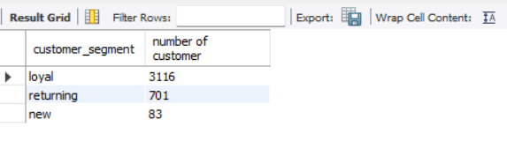
Customer segment Analysis

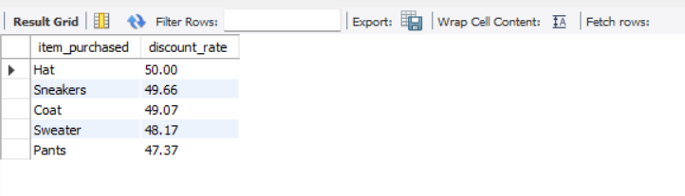
Top 5 Product with Highest Discount Rate

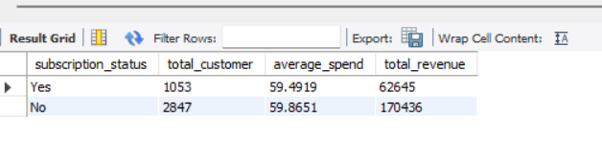
Average Spending and Total Revenue by Subscription Status

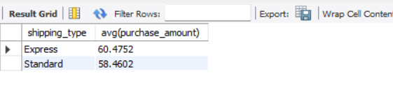
Average Spending by Shipping Type
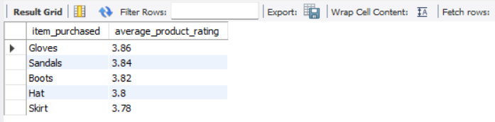

Top 5 Product by Average Review Rating

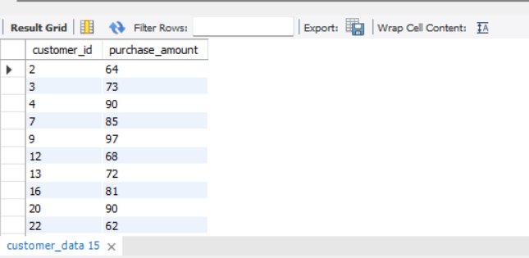

Customer who used Discount and Spent above Average

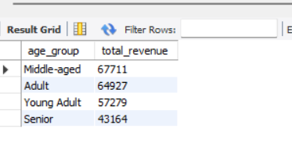
Revenue by Age Group

Power BI Dashboard

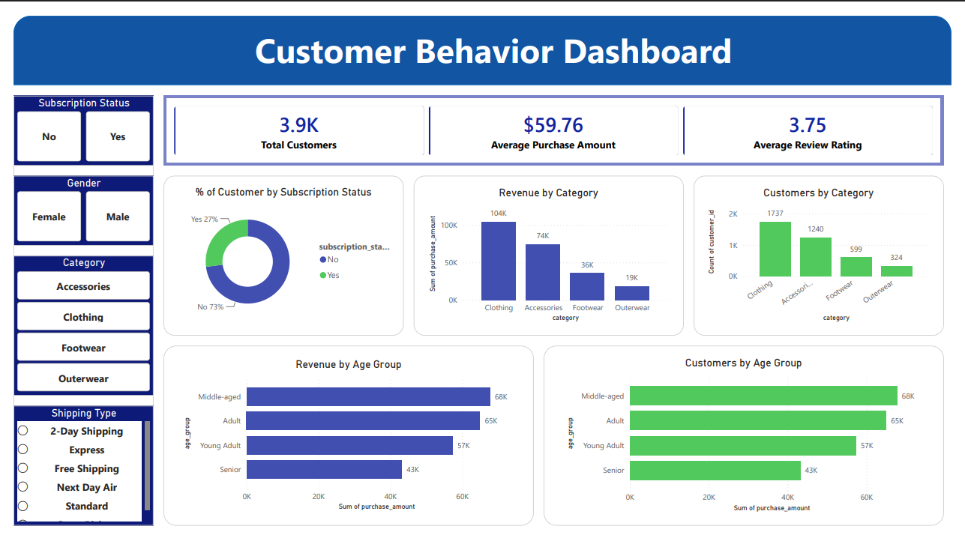
Dashboard Page 1
This page provides KPIs, category analysis, customer distribution and age group analysis.

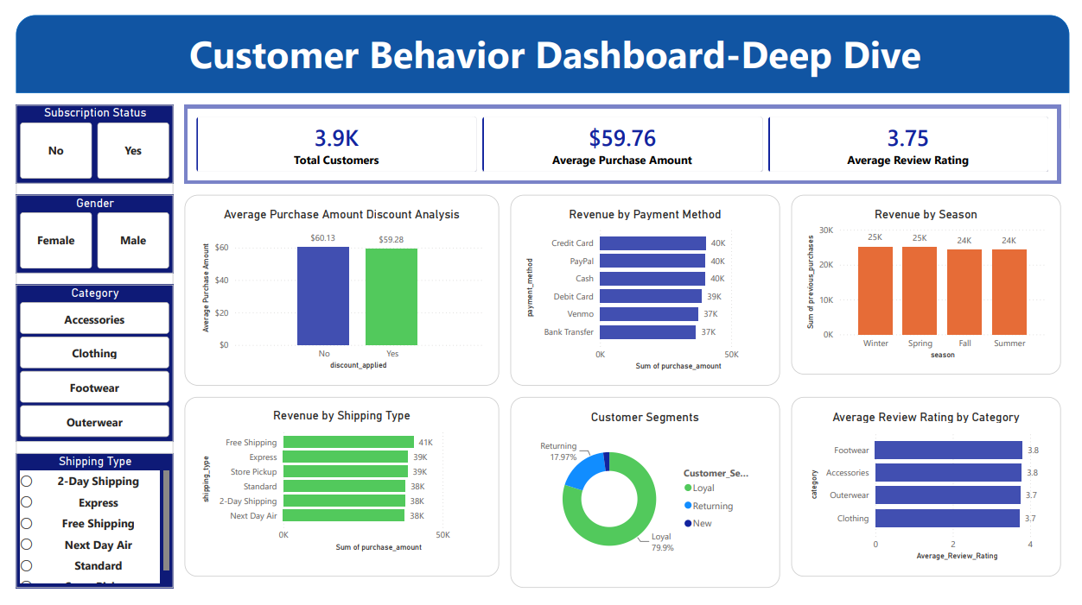
Dashboard Page 2
This page focuses on payment methods, shipping types, customer segments, review ratings and seasonal performance.

Business Recommendations
1.Focus more on middle-aged customers because they generated the highest revenue. 2. Continue promoting clothing products because they performed well. 3. Encourage loyal customers with simple reward offers. 4. Promote highly rated products on the homepage. 5. Plan seasonal offers before demand increases. 6. Review the dashboard regularly to track customer behaviour.

Conclusion
This project demonstrates a complete Data Analytics workflow using Python, MySQL and Power BI. The findings can help management improve sales and customer decision-making

